**How to Get to ECUST?**

**By Taxi**

*Tipping is not a conventional item in Chinese social cultures. You feel no pressure to do so or not after having been served.*

**From Shanghai Hongqiao International Airport**

It will take you about 42 Minutes and 76 CNY by day and 99 CNY at night to getECUST.

Distance: About **22.6 KM**

Tips: Taxis’ starting fare in Shanghai is 14 CNY for the first 3Km, and cost 2.4 CNY afterwards by day. Night fare is 16 for the first 3Km and cost 3.1 CNY/Km afterwards. Legal taxis are standard managed, licensed and metered and look just as the one in the following picture. “Black Cab” means unlicensed and unmetered, and you are not recommended to take those ones.

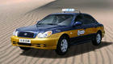

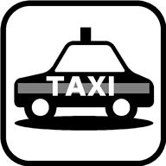

**Useful Expression**

**English:**

Hello Sir/Madam, please take me to East China University of Science and Technology,

the address is 130 Meilong Rd Xuhui District, Shanghai China.

**Chinese:**

司机师傅你好，请带我去华东理工大学，地址是上海市徐汇区梅陇路130号。